

**High Power Laser Diode**

**14-Pin SOA Butterfly**

**Fiber Module**

* OTDR
* LiDAR
* Free Space Communications
* Network Test Equipment

SemiNex delivers the highest available power at infrared wavelengths between 12xx and 19xx nm. When necessary, we will further optimize the design of our InP laser chips to meet our customers' specific optical and electrical performance needs. Diodes, bars and packages are tested to meet customer and market performance demands. Typical results and packaging options are shown. Contact SemiNex for additional details or to discuss your specific requirements.

Application

* High Output Power
* High Dynamic Range
* High Efficiency
* Standard Low Cost Package

Features

Part Number: 14BF-287

High Power 14-Pin SOA Butterfly Fiber Coupled Module

Single-Mode SOA Laser Diode

Wavelength at 1550nm

**High Power Laser Diode**

**14-Pin SOA Butterfly**

**Fiber Module**

|  |  |  |  |
| --- | --- | --- | --- |
| **Optical** | **Symbol** | **Typ.** | **Units** |
| Center Wavelength | λc | 1550 | nm (±20) |
| Output Power @1.2A* | Pout | 24.5 | dBm |
| PDL | PDL | 0.1 | dB |
| Return Loss (In) |  | 40 | dB |
| Return Loss (out) |  | 50 | dB |
| 3dB Bandwidth | BW | 100 | Nm |
| Gain @ Pin = 10μW | G | >35 | dB |
| **Electrical** | **Symbol** |  | **Units** |
| Operating Current | Iop | 1.2 | A |
| Operating Voltage | Vop | 2 | V |
| **Optical Fiber** | **Symbol** |  | **Units** |
| Fiber Core |  | 9 | μm |
| Fiber Package |  |  |  |
| Connector Type |  | FC / APC |  |
| Fiber Length |  | 1 | m |
| Pinout Type |  | Type 1 |  |
|  |  | **Range** |  |
| Operating Temp.** |  | -20 to 75 | °C |
| Storage Temp. |  | -40 to 85 | °C  **\*Optical Output Power for 14BF-290 has an SOA current @ 1.2A and Pin @ 10dBm**  **\*Optical Output Power for 14BF-287 has an SOA current @ 1.2A and Pin @ 17dBm**  *Specified values are rated at a constant heat sink temperature of 20°C.  **High temperature operation will reduce performance and MTTF.  Unless otherwise indicated all values are nominal. |

14BF-287

Specification

**High Power Laser Diode**

**14-Pin SOA Butterfly**

**Fiber Module**

**SemiNex SOAs 14BF-287**

Graphs & Data

Typical SOA 14BF L-I-V Characteristics

**High Power Laser Diode**

**14-Pin SOA Butterfly**

**Fiber Module**

SemiNex Corporation • 153 Andover Street, Suite 201, Danvers, MA 01923 • 978-326-7700 • info@seminex.com

# Mechanical Drawing

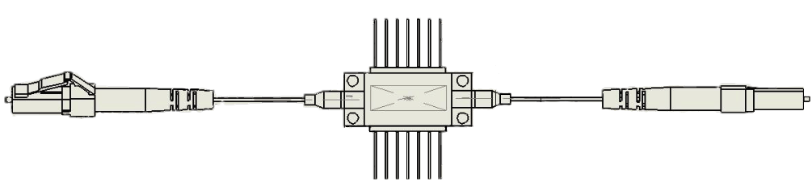

All statements, technical information and recommendations related to the product herein are based upon information believed to be reliable or accurate. The accuracy or completeness herein is not guaranteed, and no responsibility is assumed for any inaccuracies. The user assumes all risks and liability whatsoever in connection with the use of a product or its application. SemiNex Corporation reserves the right to change at any time without notice the design, specification, deduction, fit or form of its described herein, including withdrawal at any time of a product offered for sale herein. Users are encouraged to visit www.seminex.com for the latest data. SemiNex Corporation makes no representations that the products herein are free from any intellectual property claims of others. Please contact SemiNex for more information. 2016 SemiNex Corporation